



Machine learning project

Eng: Mohamed Shawky

Team 9



|  |  |  |  |
| --- | --- | --- | --- |
| **Name** | **Sec** | **BN** | **ID** |
| Ahmed Samy Ibrahim Mohamed | 1 | 8 | 9210073 |
| Kareem Samy Fawzy El Sayed | 2 | 2 | 9210838 |
| Nancy Ayman Mohamed Salahuddin | 2 | 27 | 9213410 |
| Yara Hisham Shaaban Mahrous | 2 | 31 | 9211350 |

Table of Contents

***Problem definition:*** 3

***Motivation:*** 3

***Evaluation Metrics:*** 3

***The contribution of each team member*** 3

***Exploratory Data Analysis (EDA):*** 4

*A-* *Data set distribution & outliers:* 4

*B-* *Features overall correcation:* 6

*C-* *Diabetes and features correlation:* 7

*D-* *diabetes per each feature:* 8

***Models Analysis*** 10

Outliers removal: 10

Biased and erroric dataset problem: 10

Standard scaling of feature: 10

1- Baseline(ZeroR) 11

Actual classes distribution: 11

Most frequent: 11

Uniform: 11

2- Logistic regression 12

Model overview 12

Advantages: 12

Disadvantages: 12

Model applying: 12

3- Preceptron Model: 15

Model overview 15

Advantages: 15

Disadvantages: 15

Model applying: 15

4- Random forest 18

Model overview 18

Advantages: 18

Disadvantages: 19

Model applying: 19

5- SVM: 22

Model overview 22

Advantages: 22

Disadvantages: 22

Model applying: 22

6- AdaBoost: 25

7- Learning curves: 26

# ***Problem definition:***

The problem is a binary classification task aimed at predicting whether a patient is at risk of developing diabetes based on various health indicators. Given medical and demographic data such as glucose levels, blood pressure, BMI, age, and insulin levels, the goal is to develop a predictive model that can accurately identify individuals who are likely to develop diabetes. Early detection can enable timely intervention and better disease management.

# ***Motivation:***

The motivation for addressing this problem lies in the growing global burden of diabetes, a chronic disease that can lead to severe complications such as heart disease, kidney failure, and vision loss if left unmanaged. By leveraging machine learning algorithms to predict diabetes risk early, healthcare providers can implement preventive measures, recommend lifestyle changes, and personalize treatment plans. This proactive approach can improve patient outcomes, reduce healthcare costs, and enhance the quality of life for individuals at risk. Additionally, such predictive models can support public health initiatives by identifying high-risk populations and optimizing resource allocation for diabetes prevention programs.

# ***Evaluation Metrics:***

1. Accuracy

2. Macro recall

# ***The contribution of each team member***

|  |  |
| --- | --- |
| Name | Conttibution |
| Ahmed Samy | Logistic regression- Reandom forest- ZeroR |
| Kareem Samy | Logistic regression- Reandom forest-ZeroR |
| Nancy Ayman | Visualization- preceptron-SVM-Adaboost |
| Yara HIsham | Visualization- preceptron-SVM-Adaboost |

# ***Exploratory Data Analysis (EDA):***

The first step was understanding the dataset, the features corelations and get insignts for the output of the classification modes.

## *Data set distribution & outliers:*

1. The data set distribution over the the prediction target ( diabetes) is bias toward healthy people( not diabetic) which is realistic as the majority of the humans don’t suffer for diabetes. However that is considered as a challenge for out project and biased data leads to baise model trainging and miss classification especially for the diabetes class.
2. BMI (Body Mass Index) is a key predictor of diabetes risk across different age groups. Tracking BMI trends over time can help identify the age range (e.g., 20-40 years) where individuals are most likely to be diagnosed with diabetes. This insight enables targeted awareness campaigns, encouraging people in this high-risk age group to undergo regular health screenings for early detection and prevention.

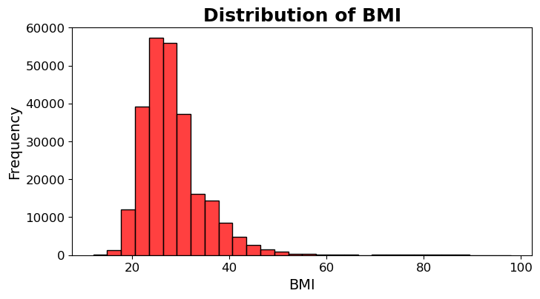

1. 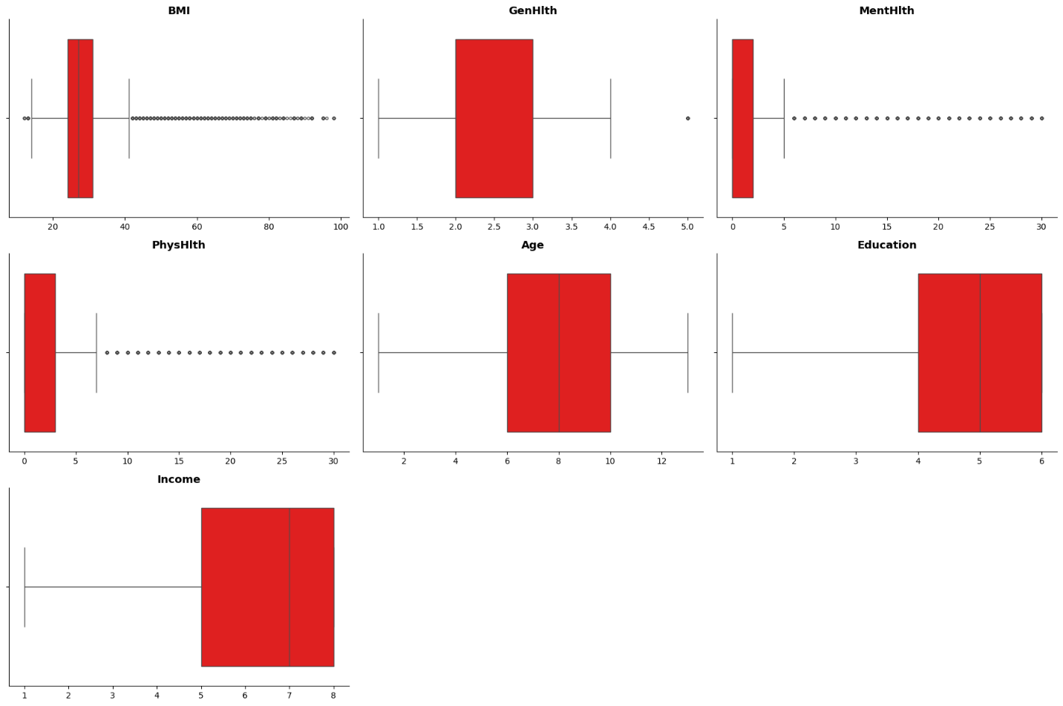Features outiers analysis:

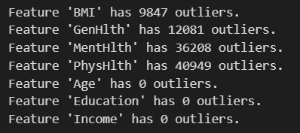

As shown there are 4 features that have outliers that needs to be elimiated. But after revising the dataset description, physHlth and MentHlth are both indicators for range (0-30) so despite being rare values they are crutical in the classification as they define a group of peaple with their characteristic.

## *Features overall correcation:*

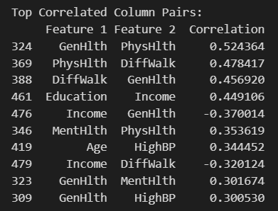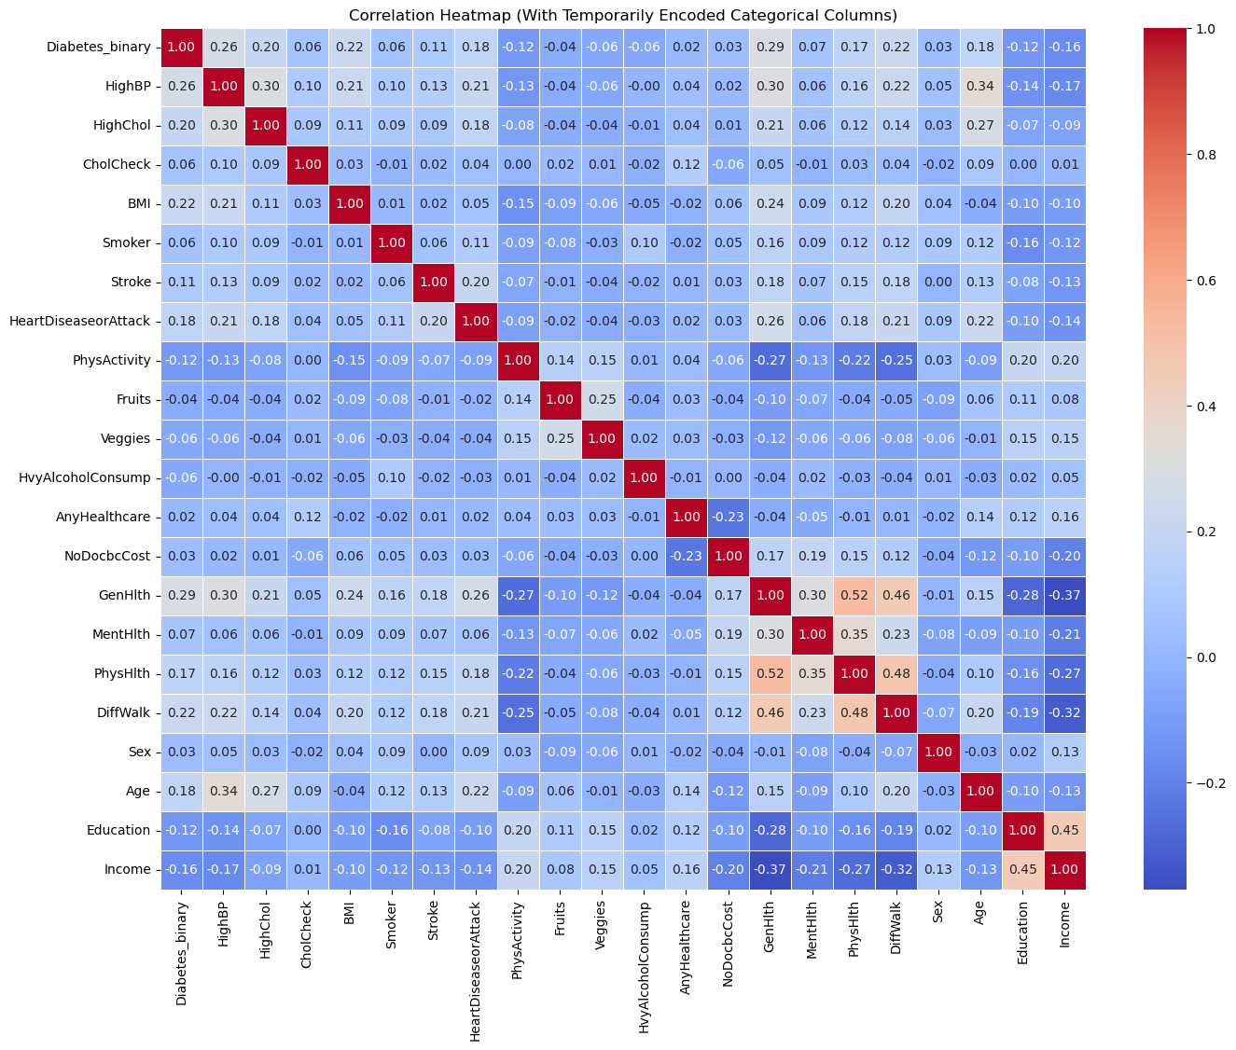

The analysis shows strong links between general health, physical health, and mobility issues, with income and age also playing key roles. These correlations highlight important diabetes risk factors while revealing some redundant features that may need combining or removing.

## *Diabetes and features correlation:*

This graph for all features correlation for diabetes:

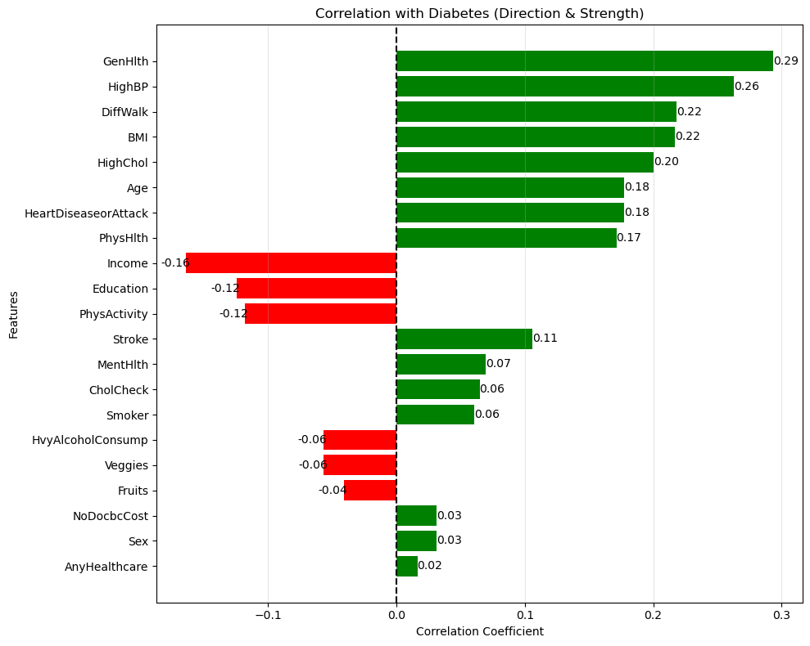

## *diabetes per each feature:*

1. 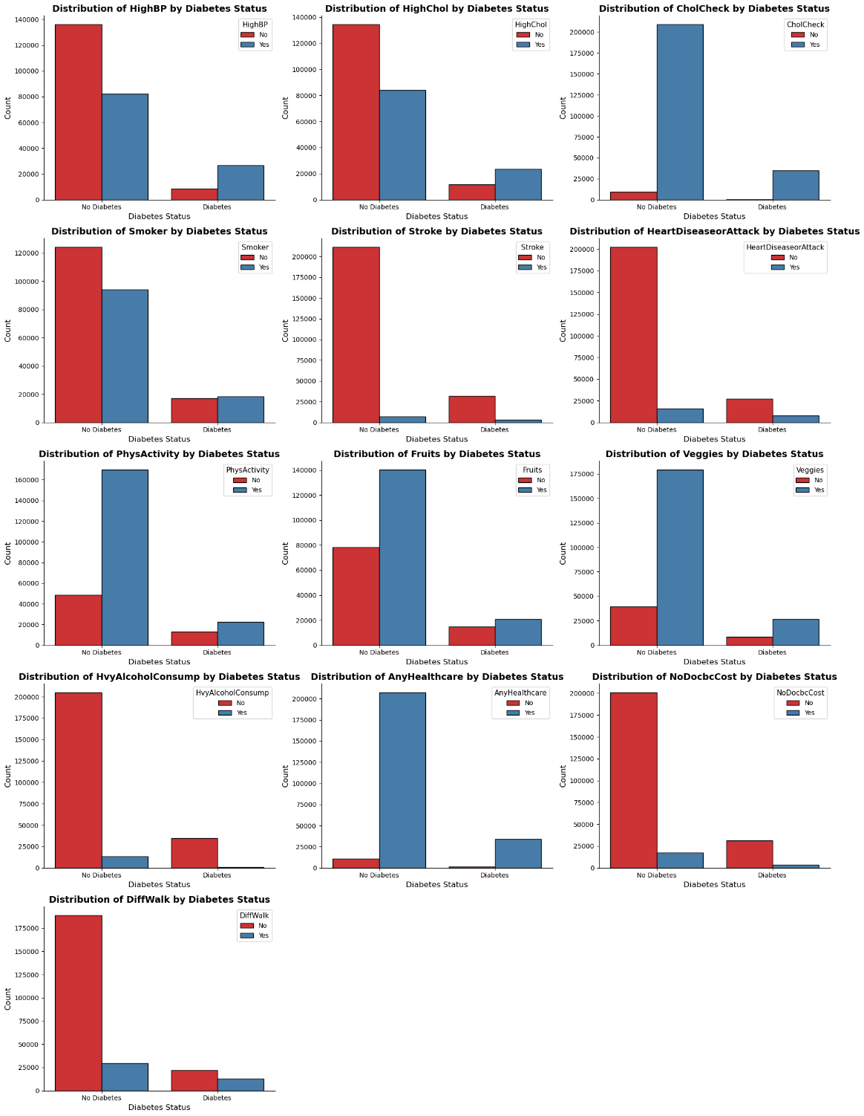The graphs below show how specific habits and medical conditions correlate with diabetes in our dataset. Each visualization compares one of these binary features against diabetes status: **Medical Conditions**, **Health Habits**, **Access Barriers**, and **Mobility Issues**
2. 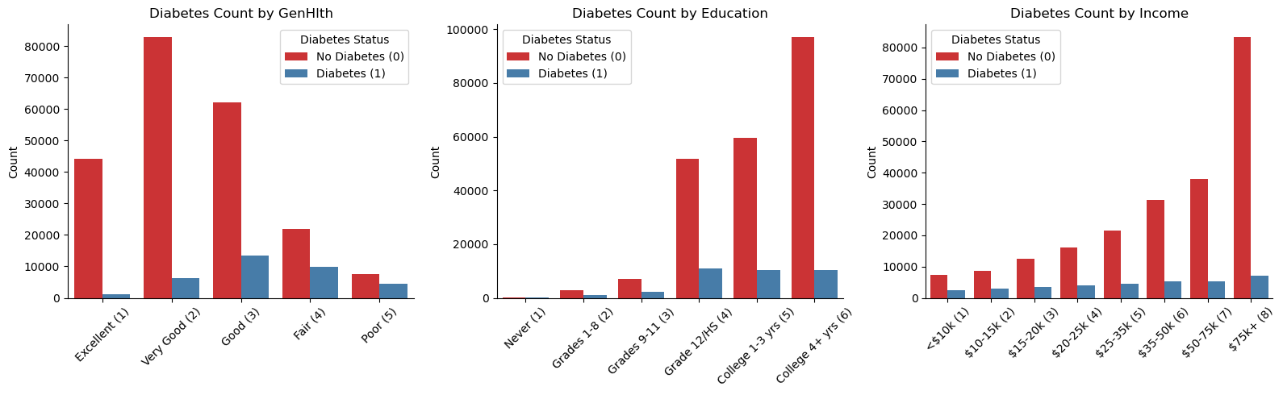diabetes distribuition grouping by general health, education or income.
3. 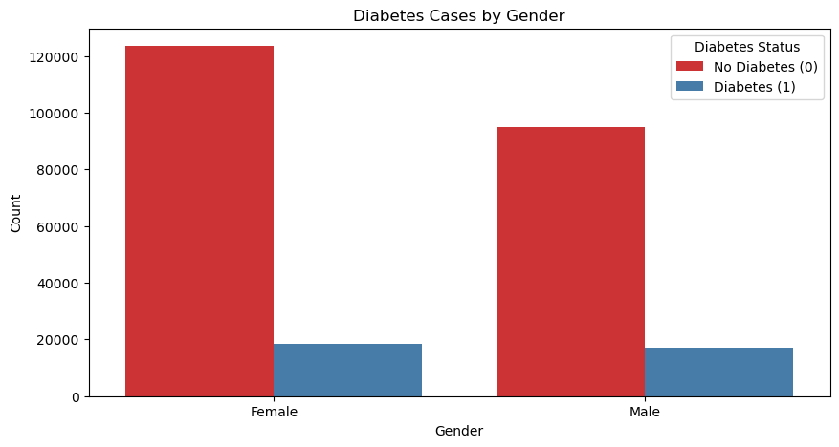Does diabetes can be classified be gender? Such question could be very helpful for classification problem.
4. The graph show that the range(20-40) most people are classified as diabetic which align with BMI distribution over ages ( more evidence for there strong correlation)

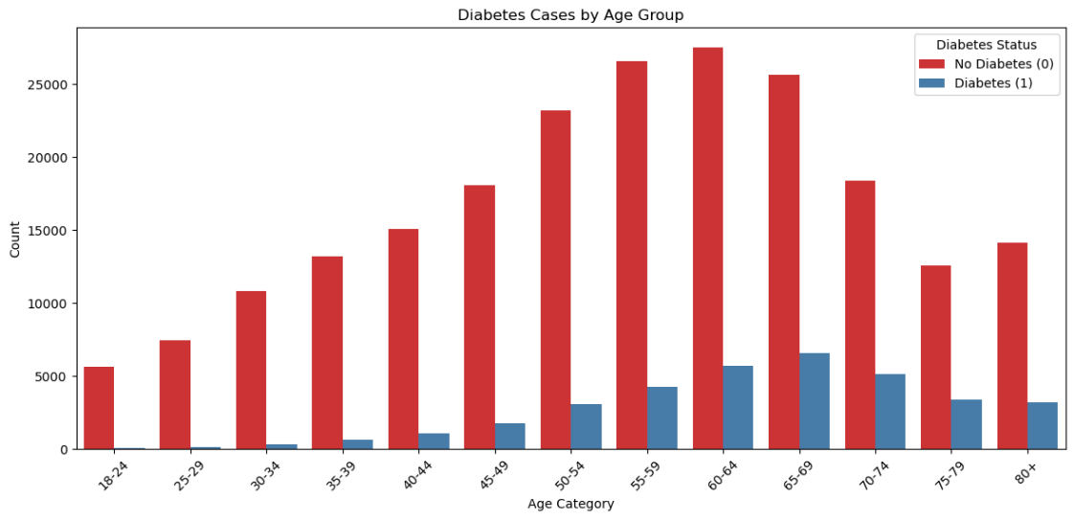

# ***Models Analysis***

All models are validated using cross validation of 5 folds

The balance range between the classes range between 1:6 as:

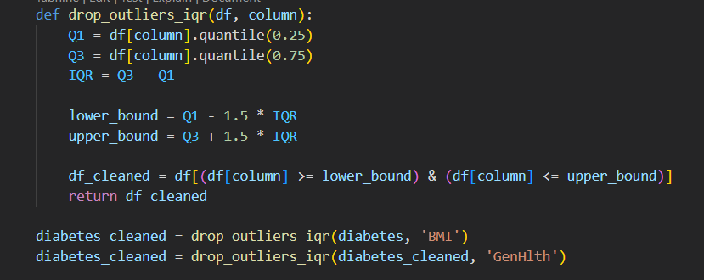Outliers removal:

## Biased and erroric dataset problem:

Since some of the data was omited and other manipulated by the datset owner, the over all accuracy of all classes wasn’t the best angle for addressing out problem. Essentially as this is a medical problem so we need to ensure minimizing FN classification for diabetic class( if some one should be diagnosed as diabetic the model can’t recklessly classify the patient as heathy but vice versa is alowed with some percent)

***New goal: get good balance between diabetes class macro recall and over all accuracy.***

## Standard scaling of feature:

Since the data scale was different for all features, most models needs approximate equal ranges so standard scaling was essential.

There was 3 scaler that was tested against the dataset for analysis and picking the best fit for the data:

* + Standardscaler (applied during the models training )
  + MinMaxscaler
  + RobustScaler

## Baseline(ZeroR)

Before working on developing machine learning models, we used some dummy models as a baseline model to compare the performance of more complex models. By comparing the performance of a complex model to that of a simple model, we can determine if the complex model is actually providing useful predictions or if it is overfitting the data. Dummy models also help identify if the problem has any inherent bias or if the dataset is imbalanced. Overall, starting with a dummy model is a good way to get a baseline understanding of the data and the problem before moving on to more complex models. We have 2 strategies:

### Actual classes distribution:

### Most frequent:

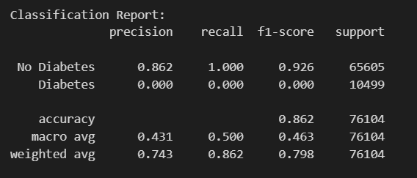Description: Always predicts the majority class

### Uniform:

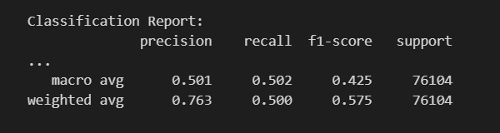Description: Random predictions with equal probability

## Logistic regression

### Model overview

Logistic regression is a powerful tool for predicting categorical outcomes. It is used in a wide variety of fields, including marketing, medicine, and finance. For example, logistic regression can be used to predict the likelihood that a customer will buy a product, the likelihood that a transaction to be fraud or not or the likelihood that a company will go bankrupt.

### Advantages:

* It is a simple method to predict categorical outcomes.
* It can be used to predict the probability of an outcome for any given combination of predictor values.
* It is relatively easy to interpret the results of a logistic regression model.

### Disadvantages:

* It can be sensitive to outliers in the data.
* It can be difficult to interpret the results of a logistic regression model when there are multiple independent variables.
* It can be computationally expensive to fit a logistic regression model with a large number of independent variables.

Overall, logistic regression is a powerful tool for predicting categorical outcomes. It is relatively easy to use and interpret, and it can be used in a wide variety of fields.

### Model applying:

##### Using SMOTE for bias compensation:

SMOTE is used rebalaning the classes, and with the help of grid search to find the best parameters for the classification.

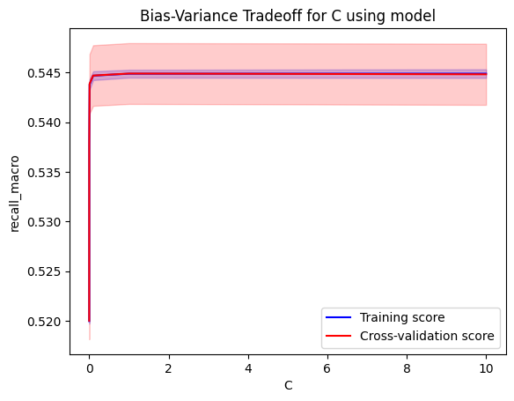

The grid seach for paramters result

*Best Parameters: {'C': 0.0001, 'class_weight': {0: 1, 1: 6}, 'penalty': 'l1', 'solver': 'saga'}*

These parameters result in test accuracy of *Test Accuracy: 36.25%* this contradicts the goal of balancing between the recall and overall accuracy. Hence the parameters were modified to:

*C=0.0001, penalty='l1', solver='saga' "*

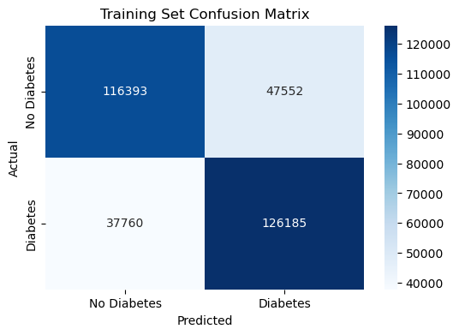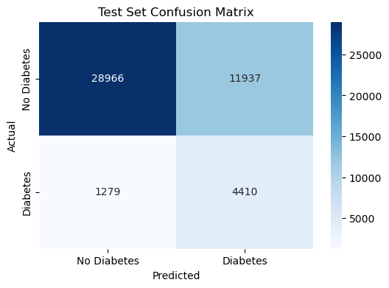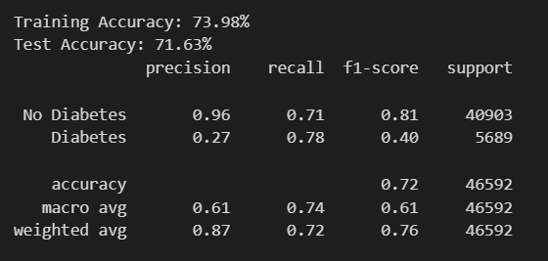theresult of mode training:

##### Training without SMOTE:

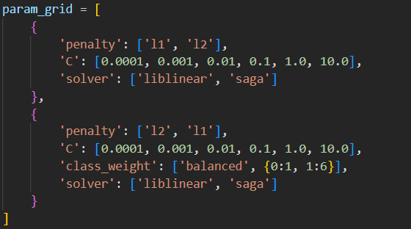Another way of balancing the classes is to use the balance attribute of the logisitic regression.

The best parameters form the grid search are:

*Best Parameters: {'C': 0.0001, 'class_weight': 'balanced', 'penalty': 'l1', 'solver': 'liblinear'}*

As its test accuray was *62.16%*

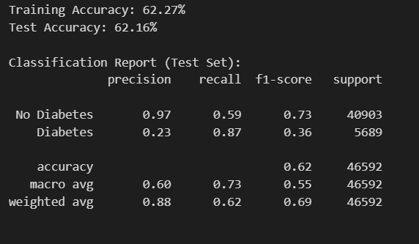So the best paramenters achieve the goal.

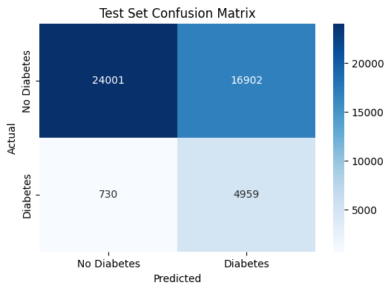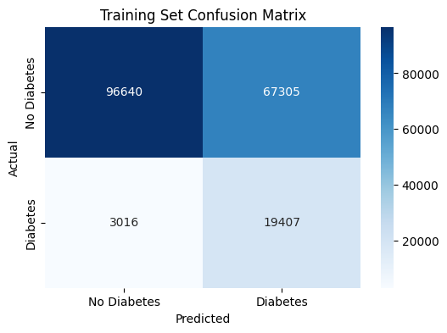

comparing SMOTE:

removing SMOTE does help in increasing recall but at the price of decreasing the accuracy by almost same factor.

##### Binary classification threshord manipulation:

Decreasing the threshold magnifies the recall as prefered but diminishes the accuracy So its not our best option.

##### Train only using top 10 correlated features:

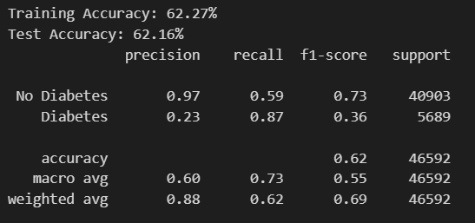

The result is almost the same as using the full dataset features

Conlusion: decreasing the dimensionality is a good choise.

###### Bias-Variance:

## Preceptron Model:

### Model overview

The perceptron is a fundamental binary linear classifier and the building block of neural networks. Introduced by Frank Rosenblatt in 1957, it serves as the simplest form of an artificial neuron, making it a key concept in machine learning and deep learning.

### Advantages:

* Efficient for linearly separable problems with low computational cost.
* Forms the basis for more complex models (MLPs, deep learning).
* Can update weights incrementally with new data (useful for streaming data).

### Disadvantages:

* Fails on non-linearly separable data (e.g., XOR problem).
* Unlike logistic regression, it doesn’t provide class probabilities.
* Requires standardized/normalized data for stable training.
* If data isn’t perfectly separable, the algorithm may not converge.

### Model applying:

##### Using SMOTE for bias compensation:

SMOTE is used in rebalaning the classes, and with the help of grid search to find the best parameters for the classification.

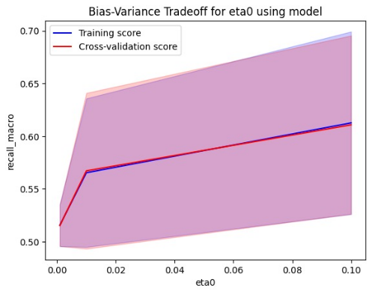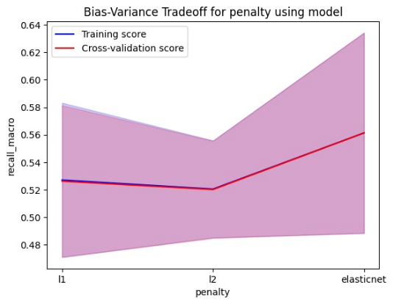Some visualizations that helps in understanding hyperparameters:

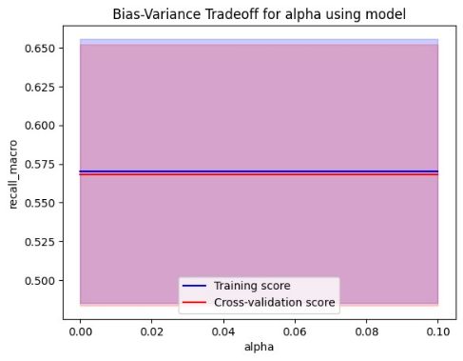

The grid seach for paramters result

*Best Parameters: {'alpha': 0.0001, 'class_weight': 'balanced', 'eta0': 0.1, 'penalty': 'l1'}*

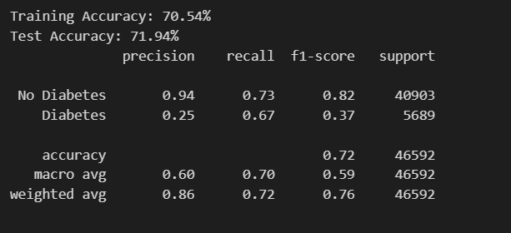These parameters result in test accuracy of *71.94%*

theresult of mode training:

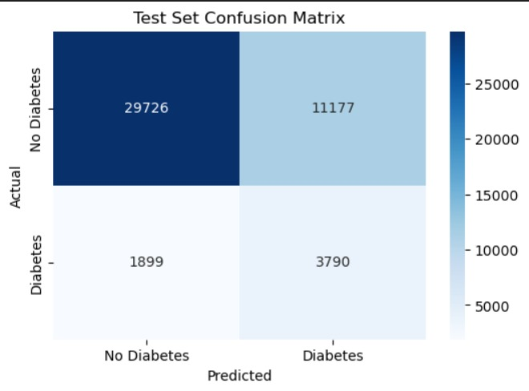

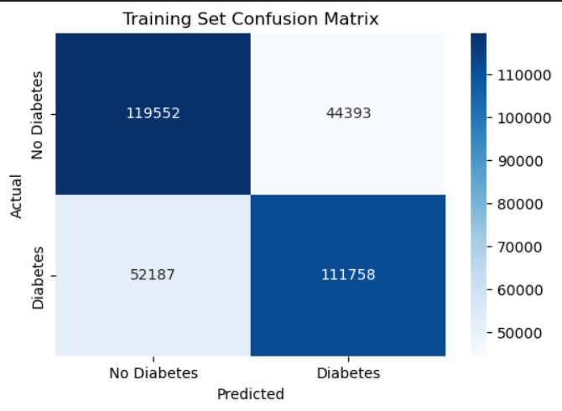

##### Training without SMOTE:

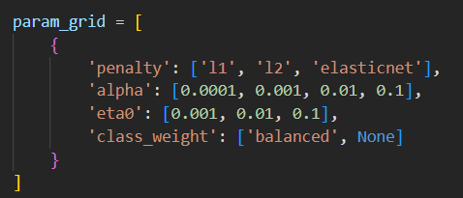Another way of balancing the classes is to use the balance attribute of the logisitic regression direclty.

The best parameters form the grid search are:

*Best Parameters: {'alpha': 0.01, 'class_weight': 'balanced', 'eta0': 0.1, 'penalty': 'l1'}*

As its test accuray was *66.16% to increase the accuracy alittle bit the parameters are:*

*random_state=42, alpha=0.001, penalty='l1', eta0=0.1, class_weight='balanced'*

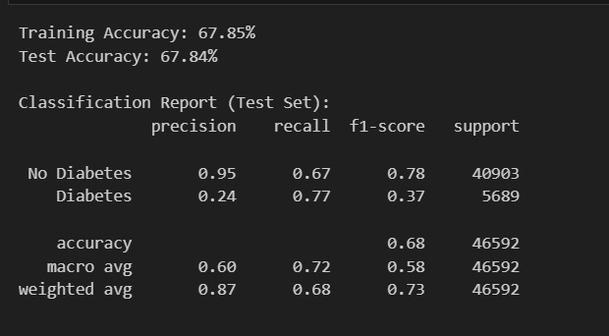

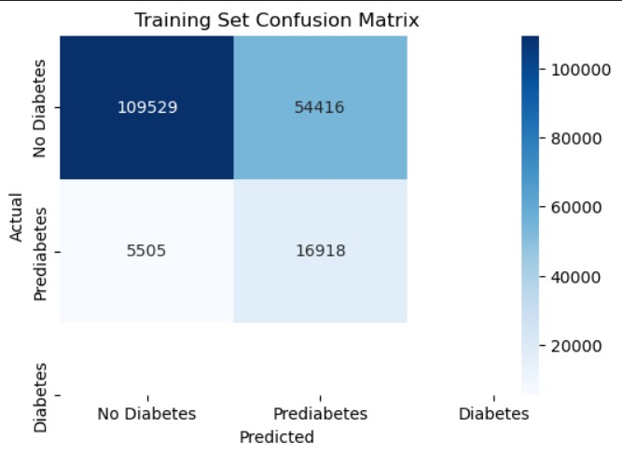

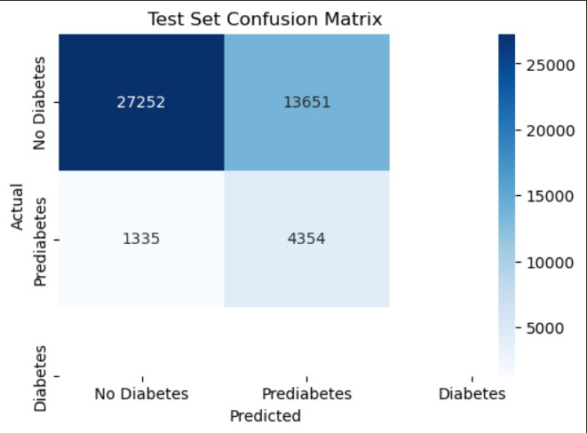

comparing SMOTE:

removing SMOTE decreased the accuracy but increased the recall.

##### Binary classification threshord manipulation:

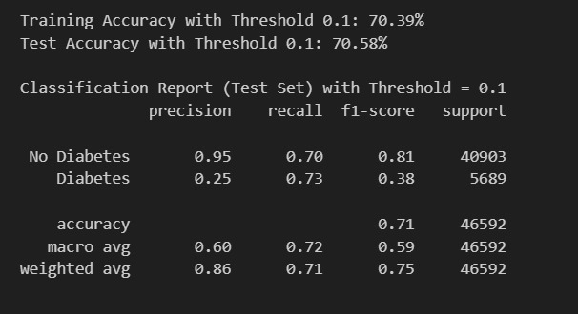

Decreasing the threshold magnifies the recall as prefered but diminishes the accuracy so its not our best option.

##### Train only using top 10 correlated features:

##### 

The result is almost the same as using the full dataset features

Conlusion: decreasing the dimensionality is a good choise.

###### A black background with white numbers AI-generated content may be incorrect.Bias-Variance:

## Random forest

### Model overview

Random Forest is a popular machine learning algorithm that falls under the category of ensemble learning methods. It is a type of decision tree algorithm that generates multiple decision trees and combines their predictions to produce the final output.

### Advantages:

* Random Forest has a high accuracy rate due to the combination of multiple decision trees.
* It is robust to outliers and noise in the dataset.
* Random Forest provides a measure of feature importance, which can be useful for feature selection and interpretation.
* It is able to handle large datasets and can be parallelized for faster processing.
* The combination of multiple decision trees reduces the risk of overfitting and increases generalization.

### Disadvantages:

* Random Forest models are often difficult to interpret due to their complexity and the number of decision trees.
* The training and prediction process of Random Forest can be computationally expensive, especially for large datasets.
* The memory usage of Random Forest can be high due to the number of decision trees.
* Random Forest can be biased towards the majority class in imbalanced datasets, leading to lower accuracy for the minority class.

### Model applying:

##### Using SMOTE for bias compensation:

SMOTE is used rebalaning the classes, and with the help of grid search to find the best parameters for the classification. The grid seach for paramters result:

*Best Parameters: {'class_weight': 'balanced', 'max_depth': 10, 'min_samples_leaf': 2, 'min_samples_split': 2, 'n_estimators': 200}*

*Test Accuracy: 82.06%*

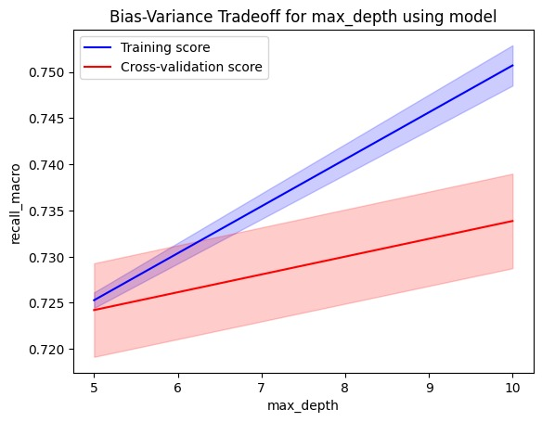

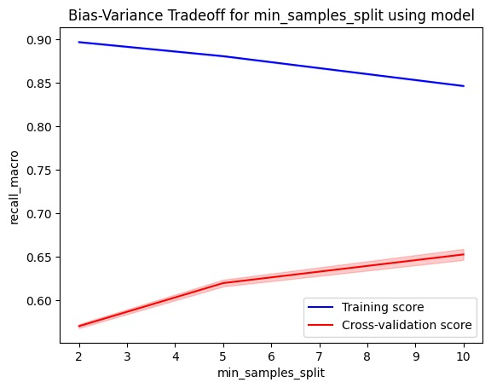

theresult of mode training:

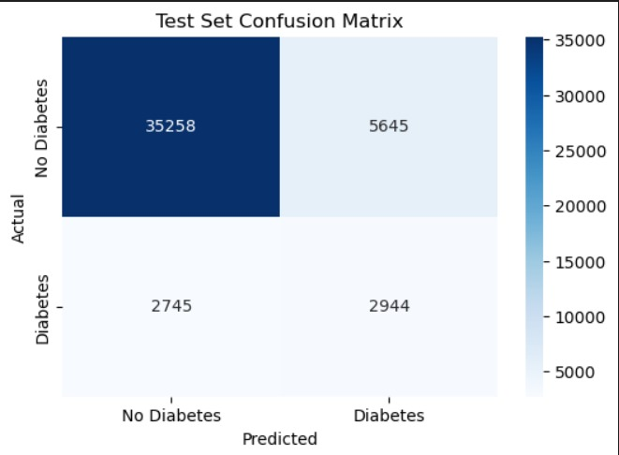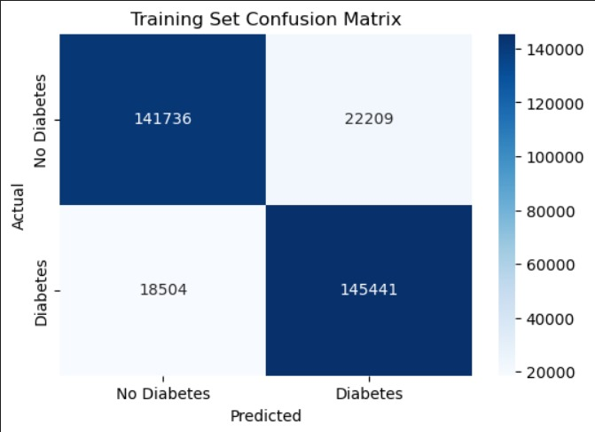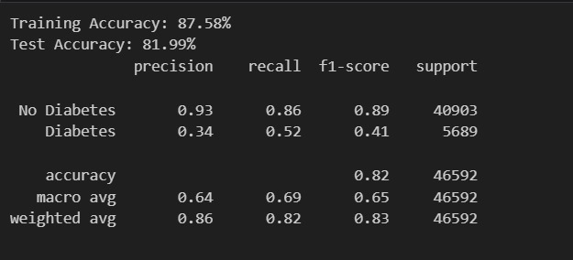

##### Training without SMOTE:

Another way of balancing the classes is to use the balance attribute of the sklearn random forest direclty. The grid parametes are the same as SMOTE grid params

The best parameters form the grid search are:

*Best Parameters: {class_weight='balanced', criterion='entropy', max_depth=10, min_samples_leaf=4, min_samples_split=10,n_estimators=100 }*

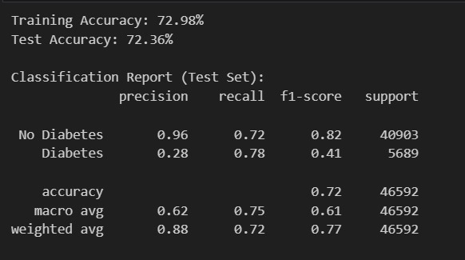As its test accuray was *72.36% (meets the goal)*

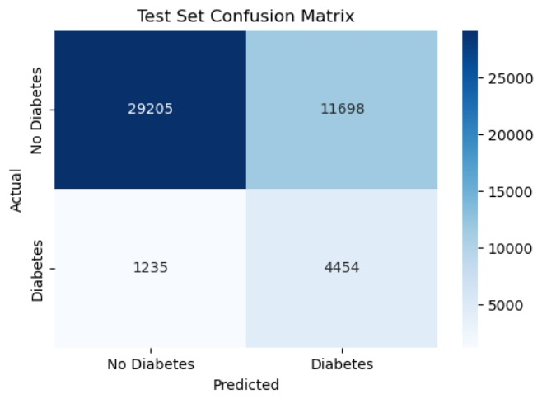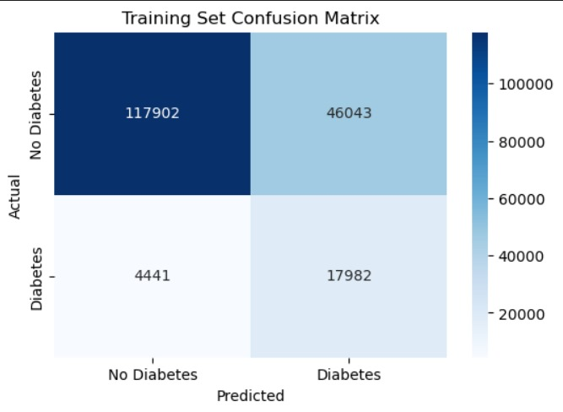

##### Binary classification threshord manipulation:

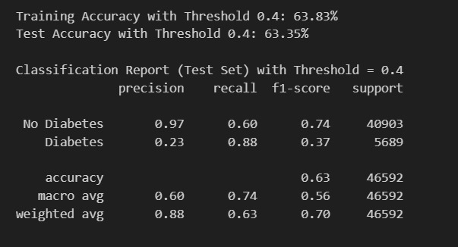

Decreasing the threshold magnifies the recall as prefered but diminishes the accuracy so its not our best option.

##### Train only using top 10 correlated features:

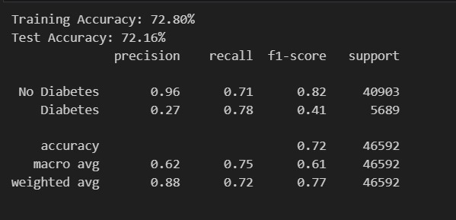The result is almost the same as using the full dataset features

Conlusion: decreasing the dimensionality is a good choise.

###### Bias-Variance:

## SVM:

### Model overview

Support Vector Machines (SVMs) are a class of supervised learning algorithms used for classification and regression analysis. SVMs work by finding the hyperplane that best separates the data into different classes. The optimal decision boundary is the hyperplane that maximizes the margin between the two classes. In the case where the data is not linearly separable, SVMs use a kernel trick to map the data into a higher-dimensional space where the data can be linearly separated.

### Advantages:

* SVMs can perform well in high-dimensional spaces, making them useful for solving complex problems with many features.
* SVMs are less prone to overfitting than other classification algorithms because they try to maximize the margin between classes, which helps prevent the model from being too closely fit to the training data.
* SVMs can be used for both linear and nonlinear classification and regression tasks, and different kernel functions can be used to handle different types of data.
* SVMs are computationally efficient and can work well with small and large datasets.

### Disadvantages:

* SVM performance depends heavily on the choice of kernel, which can be challenging to choose correctly.
* SVMs are sensitive to the scale of the input features, so data preprocessing is required to standardize the features.
* SVMs can be computationally intensive, particularly for large datasets and complex kernel functions.
* SVMs are designed for binary classification problems, which means they need to be modified for multi-class classification tasks.

### Model applying:

Given that SVM models are computationally intensive to train, using one device to find good parameters is inefficient. So the parameters search was distributed over multiple devices. The best reached paramters were selected as the best parameters for the data.

##### Using SMOTE for bias compensation:

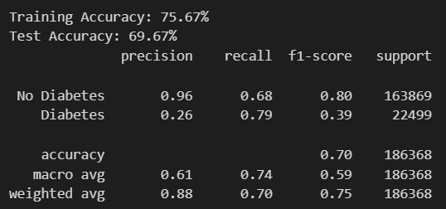

##### Training without SMOTE:

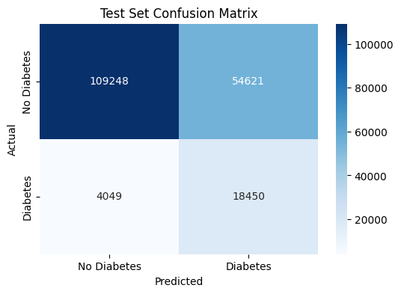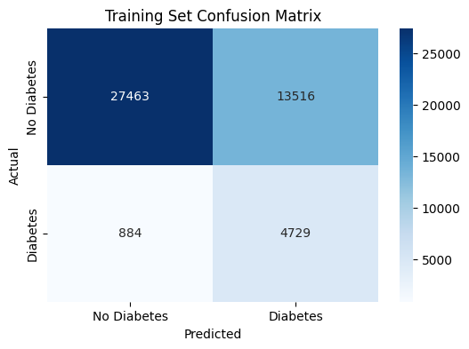

##### Binary classification threshord manipulation:

##### Train only using top 10 correlated features:

## AdaBoost:

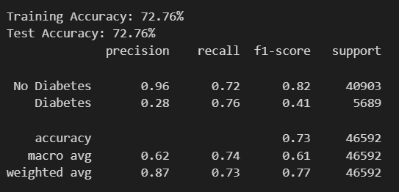Adaboost model what trained over 10 most correlated features whith 100 estimators for logistic regression (balanced weights)

###### A black background with white numbers AI-generated content may be incorrect.bias and variance:

## Learning curves:

the graphs show the training error (Ein) and validation error (Eval) as a function of the training set size. the models is on average working well as both error are almost the same.

